**Continuous Integration Overload: Dealing with many projects in Jenkins.**

Running an amazing CI tool like Jenkins is a great for productivity, especially when you’re testing throughout multiples stages of development. But what happens when you need to test multiple stages of development, with multiple features and for more than a few projects?

You may find yourself cutting and pasting some Jenkins Execution shell commands from a master template, or rewriting them by hand for each and every instance.

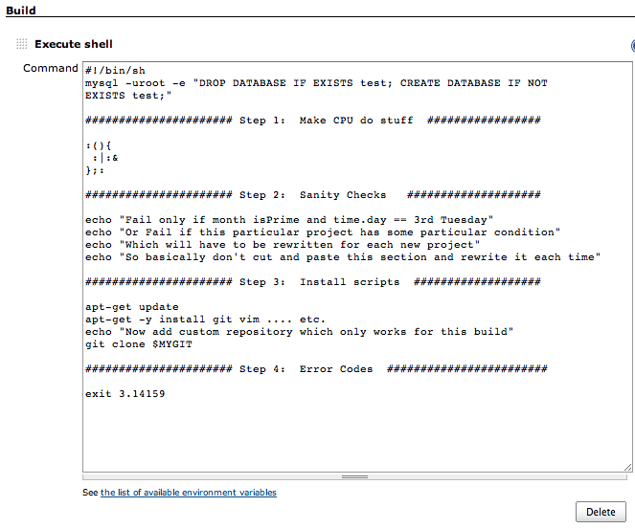

You have to manually set up each project with each environment, and then remember which template you’re using which is frustrating and, more importantly, time consuming work.

**In comes Fabric to save the day.**

Fabric is a python based superhero that can deploy, update, sudo or pretty much anything you can do with a bash script, but over multiple ssh sessions! This means that you can design one master fabric script and have it create or maintain many instances or build environments.

**Integrating Fabric with Jenkins.**

Using the same helpful Execution shell, we can call a fabric script and pass it parameters with Jenkins’ parameterization.

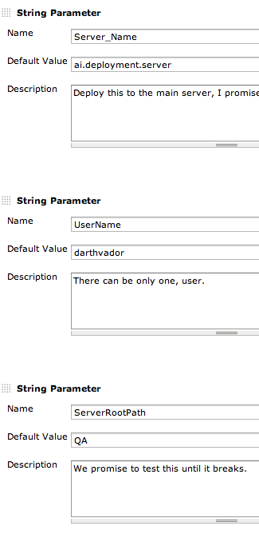

And then the Execution Shell.

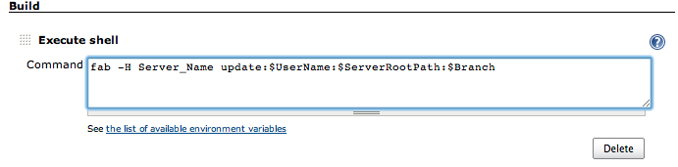

Now Save and Build! And the next time you push a new feature, just specify the parameters for Jenkins and you’ll never have to worry about individual instance configurations.

Here’s a quick and dirty FAB file that we can use to control many of our deployments.

